**Bird migration** **connects regions but does not raise local prevalence and richness of avian haemosporidian parasites**

Daniela de Angeli Dutra¹*, Antoine Filion¹, Alan Fecchio², Érika Martins Braga³, Robert Poulin¹

[danideangeli@live.com*](mailto:danideangeli@live.com*) https://orcid.org/0000-0003-2341-2035

afilion90@gmail.com

[alanfecchio@gmail.com](mailto:alanfecchio@gmail.com) https://orcid.org/0000-0002-7319-0234

embraga@icb.ufmg.br

robert.poulin@otago.ac.nz

1.Department of Zoology, University of Otago, Dunedin, New Zealand

2.Programa de Pós-graduação em Ecologia e Conservação da Biodiversidade, Universidade Federal de Mato Grosso, Cuiabá, MT 78060-900, Brazil

3.Departamento de Parasitologia, Instituto de Ciências Biológicas, Universidade Federal de Minas Gerais, Brazil

**\*Correspondence:**

Daniela de Angeli Dutra

danideangeli@live.com

**Abstract :** Migration has an important impact on the transmission of pathogens around the world since migrants can introduce pathogens to new areas and hosts. Hence, migratory birds can disperse pathogens thought their routes. Indeed, one of the most prevalent, diverse and important bird pathogens are haemosporidian parasites. South America is a perfect model to investigate the role of migration and parasite dispersal as it holds a great richness of resident and migratory birds(~3500 species). Considering this, we hypothesize that (1) migratory birds spread parasite lineages along their routes, and (2) localities crossed by more migratory routes have greater prevalence and richness of haemosporidian. For the first hypothesis, we tested whether parasite lineages found (i) only in migratory birds, (ii) in both migrants and residents, and (ii) only in residents, differ in their frequency of occurrence among localities. For the second hypothesis, we tested for a relationship among localities between the overall local haemosporidian parasite richness and prevalence, and the proportion of migratory birds individuals passing through a locality. To this end, we used a 13200 birds plus data from MalAvi database and used Bayesian multi-level models and mixed models to test difference in parasites lineage compared to the migratory status of their host . Our results illustrate parasites shared by resident and migratory species are the most widespread, confirming the importance of migration in parasite dispersal. However, we observed no relation for parasite richness and a negative relation for prevalence per bird species and the proportion of migrants. Therefore, we show that parasites can be dispersed thought bird migration, but it does not raise local prevalence and richness of avian haemosporidian parasites.

1.Introduction

Migration has an important impact on the transmission of disease across the world because migrant species can potentially disperse pathogens and parasites between two or more locations and be exposed to more infectious agents (Bauer and Hoye 2014). In this way, migrant species might play an important role in the evolution and distribution of parasites and promote the spread of pathogens to new areas and new hosts species. Besides that, human introduced pathogens and host species can decrease the fitness and survival of resident and native species, compromising the population abundance of local species and reducing community richness (Callaway and Ridenour 2004, Prenter et al. 2004). Conversely, the spread of pathogens might increase host richness by reducing competition pressures and, therefore, avoiding competitive exclusion. Hence, pathogen spread might act as an environmental filter to new species colonization. Several studies have documented the influence of migratory birds on the spread of important pathogens with some of these able to infect humans (Alekseev et al. 2001, Morshed et al. 2005, Poupon et al. 2006, Hellgren et al. 2007, Lindeborg et al. 2012, Ricklefs et al. 2017). Thus, the migratory behavior of birds may influence directly host local richness and population size.

Recently, it was suggested that avian malaria parasites and related haemosporidians, could be used as geographical markers for migratory birds (Marzal 2012). Previous research has demonstrated differences in the timing of the main occurrence of haemosporidian infection in migrating birds. These studies have suggested that differences in haemosporidian lineages could indicate whether birds had become infected in different areas (Marzal 2012). Because migratory birds connect distinct geographic regions they might influence local pathogen transmission. Since most haemosporidians cause life-long infections, parasites may travel across long distances with their bird host during migration. This would therefore allow them to infect new vectors and new avian hosts in novel environments (Fecchio et al. 2020). Indeed, migratory species are known for their potential to connect distant habitats and transfer large amounts of biomass and nutrients between ecosystems (Altizer et al. 2011). Furthermore, O’Connor et al. 2020 have demonstrated that migratory birds do not possess higher immune gene richness in wetter areas, which are usually associated with higher risk of avian malaria (Zamora-Vilchis et al. 2012, Gonzalez-Quevedo et al. 2014). Thereby, migratory birds may be more susceptible to pathogens in those regions. For this reason, it might also be expected that migratory birds harbor a more diverse range of parasites and might be more susceptible to parasite infections.

South America comprises different types of biomes, which hold a great richness of native resident and migratory bird species, thus making it an ideal system to investigate such questions. Previous research has documented the prevalence of avian malaria in different regions of Brazil, and markedly different prevalence for *Plasmodium* spp have been reported between these regions (Braga et al. 2011). Indeed, the most prevalent avian haemosporidian parasite genus in this region is *Plasmodium* (Braga et al. 2011). *Plasmodium* parasites present higher host-shifting rates than other bird haemosporidians (Hellgren et al. 2007), which could certainly contribute to their increased dissemination by migratory birds into new areas. Indeed, host-shifting of a *Plasmodium* species from domestic chicken to wild and native birds has already been reported in South America (Ferreira-Junior et al. 2018).

Furthermore, the great avian richness (~3500 species) and abundance in South America (Remsen et al. in press) could also enhance the probability of parasite host-shifting between migratory and resident birds, given the likely presence of susceptible birds in any particular area. Besides that, the great richness and abundance of vectors (Consoli and Oliveira 1994) could also increase the chances of host-shifting between migratory and resident birds as it increases the chances of compatible vectors being present. Thus, these features make the South American avian haemosporidians a great model to investigate the putative transmission of pathogens via host migration in nature.

In this context, the main goal of this study is to evaluate the influence of migratory birds on the spread of haemosporidian parasites in South America. Specifically, we evaluated the hypothesis that (1) migratory birds spread parasite lineages along their migratory routes, and (2) localities crossed by more migratory routes have greater prevalence and richness of haemosporidian lineages. For the first hypothesis, we tested whether parasite lineages found (i) only in migratory birds, (ii) in both migrants and residents, and (ii) only in residents, differ in their frequency of occurrence among localities. Due to the fact migrants can carry parasites from many sites and infect resident birds, we predicted that parasite lineages using migratory birds will occur in a greater percentage of localities than those using only resident birds. Moreover, migration behavior increases the exposure of birds to more parasite lineages and hence their contact with different parasites as migrants pass through regions that harbor different parasite communities. Therefore, we expect higher haemosporidian richness and prevalence in regions with more migratory birds. For the second hypothesis, we tested for a relationship among localities between the overall local haemosporidian parasite richness and prevalence, and the proportion of migratory birds passing through a locality.

2. Methods

2.1 Dataset

All the analyses were performed using a dataset containing ~13200 bird blood samples accounting for 916 species from 63 different locations sampled from 2005 to 2018 in South America obtained from Lacorte et al. 2013, Ferreira et al. 2017, Fecchio et al. 2019 and unpublished data. In addition, haemosporidian lineages from MalAvi database (<http://130.235.244.92/Malavi/>, Bensch et al. 2009) were included from South American regions (Figure 1, Supplementary material). Combining both datasets, we obtained a total of ~2800 sequenced parasites with 668 distinct lineages representing different 506 host species and 156 localities (all lineages belonging to one of these three genera: *Plasmodium*, *Haemoproteus* and *Leucocytozoon*). Each locality was assigned to a biome based on the classification of Turchetto-Zolet et al. 2013. The parasite prevalence was estimated using PCR diagnostic protocols described by Hellgren et al. 2004 and Fallon et al. 2003. The parasite lineages were identified by the PCR protocol described by Hellgren et al. 2004. This protocol produces a *cyt b* fragment of 478 bp. The birds present in each locality were classified into three ecological classes: (1) resident; (2) partial migrant and (3) full migrant, according to the Brazilian Committee of Ornithology Records - CRBO 2014, Somenzari et al. 2018 and BirdLife International (<https://www.birdlife.org/>).

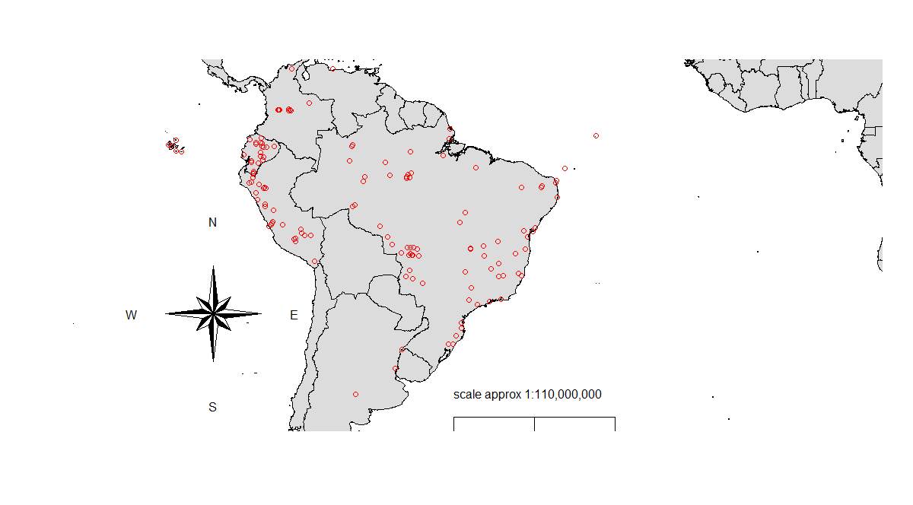

Figure 1: Bird collection points. Collection points comprises a total of 156 areas combining our dataset and the MalAvi database.

2.2 Potential correlates of prevalence and richness

*Spatial and temporal correlation*

All analyses were conducted in R (R Core Team, 2019). We determined whether there was significant spatial autocorrelation for prevalence and parasite richness in our dataset by calculating the Moran Index value. In order to estimate this index, we combined the coordinates data into a matrix and employed the function “Moran.I” from the “Ape” package (Paradis and Schliep 2018). Temporal correlation analyses were performed using linear models, to determine whether prevalence or richness estimates varied throughout the sampling period (2005–2018). For parasite prevalence, we conducted a mixed linear model using package “lme4” and the function “lmer” (Bates et al. 2015). Firstly, we grouped the data by year and location employing. Then, we compared the prevalence among years of collection considering number of birds collected and location as variables. In order to estimate temporal correlation for parasite richness, we performed a simple linear model using the “lm” function.

*Phylogenetic Signal*

In order to estimate the phylogenetic signal among prevalence and richness estimates for the bird species in our dataset, we downloaded the file AllBirdsHackett1.tre from <https://birdtree.org/> website. Using the “treeman” package (Bennett et al. 2017), we created a treeman file containing all trees from the original file. Then, we randomly selected 100 trees. This new file was converted from treeman to a phylo file, from which we extracted one single random tree. We grouped our data per species and eliminated all bird species from the phylo tree which were not present in our dataset. Using the “match” function from the “picante” package (Kembel et al. 2010), we matched the species between the tree and our dataset. Then, we calculated Pagel’s lambda (λ) to evaluate the phylogenetic signal among bird species in our dataset, for both haemosporidian prevalence and parasite richness. Values of λ can range between 0 (no phylogenetic signal) and 1 (strong phylogenetic signal). In order to estimate lambda (λ), we applied the “phylosig” function from the “phytools” package (Revell 2012).

*Climate variables*

We used mean precipitation seasonality, annual mean temperature (ºC) as predictors in the mixed models. Aiming to these climate data we used R to extract it from Worlclim database (<https://worldclim.org/version2>). Using package “raster”, we extracted Worlclim data using “getData” function, then we selected only the data from the 63 localities present in our dataset since climate variables were applied only in mixed model analyses, which MalAvi database data was not employed.

2.3 Statistical Analyses

The spatial and temporal autocorrelation analyses revealed there is no substantial effect of time or space on parasite richness, however, for prevalence, we observed a Moran Index effect of 0.15, and for this reason, locality was used as a random effect in our second mixed model to control for stochastic characteristic of localities. Likewise, considerable phylogenetic signals were observed among bird species for prevalence (0.49) and parasite richness (0.17). Considering this, phylogenetic covariation was added in Bayesian analyses and we analysed the prevalence using species as a factor in the second mixed model.

*Bayesian model*

In order to determine whether migratory birds spread parasite lineages along their migratory routes and to evaluate the parasite connectivity among localities due to migratory behavior, we conducted used multi-level modeling (MLM) using the “brms” package (Bürkner 2017) to evaluate the percentage of localities in which haemosporidian lineages occurred depending on whether they were found only in resident birds, only in partial migrant and fully migrant birds, or in both residents and migrants. We decided to use brms function due to the fact it is possible to measure for host phylogeny and to statistically estimate the percentage of localities lineages are distributed according to their host status. Firstly, using the “ape” package (Paradis and Schliep 2018), we computed the phylogenetic expected variances and covariances from our bird species and incorporated this to control for phylogenetic effects in our Bayesian model. Secondly, we applied the “get_priors” function to fit the priors for our model. We considered as independent and dependent variables bird migratory categories and percentage of localities in which each lineage was present, respectively. We also used as fixed variables the number of birds per site and host richness. As our Moran Index value for spatial autocorrelation of parasite richness among localities was low (-0.0008), we did not consider locality as a variable in our model and also did not use model correction for locality coordinates. Thus, we ran the model applying the “Beta” family, 4 chains with 4000 total iterations per chain and 2000 of warmup interactions. The model results were plotted using the “conditional_effects” function to visualize the predictions of the population-level effects. We ran three models: one for all three parasite genera combined, one for *Plasmodium* lineages only, and one for *Haemoproteus* lineages only.

*Mixed models*

Two mixed models were performed to estimate whether localities with more migratory birds have greater prevalence and richness of haemosporidian lineages. We chose to use mixed models since we could incorporate fixed effects and evaluate those variables into the models. With this objective, we employed the “lmer” function from “lme4” package (Bates et al. 2015). In the first model, we considered parasite richness as the dependent variable and percentage of migratory bird individuals (i.e., percentage of migratory individuals out of all individual birds sampled in a locality) as independent variable. Local host richness (i.e., number of bird species sampled per locality), prevalence, percentage of migratory species and number of migrant individuals were considered fixed variables. Further, number of individual birds tested for infection per site, biome, mean precipitation and temperature were settled as a random variables. In this model we did not use MalAvi dataset, but only our dataset described above since it possesses more information regarding the localities, such as prevalence data and host richness. We ran three models: one for all three parasite genera combined, one for *Plasmodium* lineages only, and one for *Haemoproteus* lineages only.

In the second model, we analysed the prevalence of infection in each bird species between localities. For this, we considered local prevalence in each bird species as our dependent variable and local percentage of migratory bird individuals as our independent variable. Parasite richness, number of migrants and percentage of migrant species were employed as fixed variables. Further, we used biome, locality, number of birds per species and mean precipitation and temperature as random variables. In this model, we filtered our data in order to include only species with 10 or more bird individuals analysed. For this second model we again used only our dataset described above and excluded data from the MalAvi database, since the latter presents only positive and sequenced samples. Again, we ran three models: one for all three parasite genera combined, one for *Plasmodium* lineages only, and one for *Haemoproteus* lineages only.

3. Results

Our Bayesian model analyses revealed the lineages shared by resident and migratory species are the most widespread spatially, as they are found in a higher percentage of locations (Figure 2, Table 1). When considering all haemosporidian genera together, we observed that the lineages shared by all three categories (resident, partial migrant and full migrant) are the most widespread, followed by those shared between residents and either type of migratory species. Nevertheless, despite the fact lineages shared by migratory species and residents are more widely distributed, lineages present in only residents, migratory or partially migratory species presented similar spatial distribution in our model.

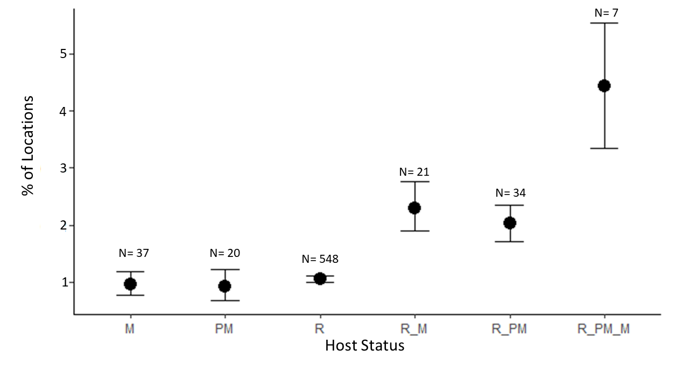

Figure 2. Mean (±SE) percentage of localities in which haemosporidian lineages are detected according to the type of birds in which they are found. M = full migratory, PM = partial migratory, R = resident, R_M = resident and full migratory, R_PM = resident and partial migratory and R_PM_M = resident, partial migratory and full migratory. Number of lineages in each of the six categories are shown on the graph.

When repeating these analyses separately for the two main parasite genera, we observed differences in the pattern of distribution between *Plasmodium* and *Haemoproteus*. For *Plasmodium* parasites, we observed a much greater spatial distribution of lineages shared by all three host categories, followed by the lineages shared by migrant or partial migrant and residents (Figure 3, Table 2). *Plasmodium* spp. lineages occurring in the three bird categories were present in 12.6% (SE = ±1.2%) of localities, a much higher value than for other lineages. However, for *Haemoproteus* lineages, we observed greater spatial distribution of lineages shared only by migrant or partial migrant and resident birds. The lineages shared by all three bird categories and those occurring in only one bird category had similar distributions among localities (Figure 4, Table 3).

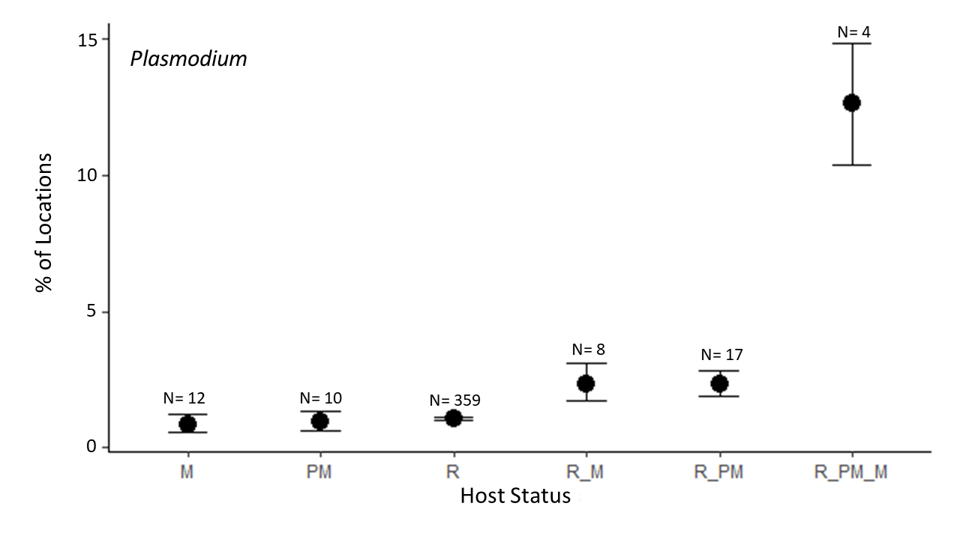

Figure 3: Mean (±SE) percentage of localities in which *Plasmodium* lineages are detected according to the type of birds in which they are found. M = full migratory, PM = partial migratory, R = resident, R_M = resident and full migratory, R_PM = resident and partial migratory and R_PM_M = resident, partial migratory and full migratory. Number of lineages in each of the six categories are shown on the graph.

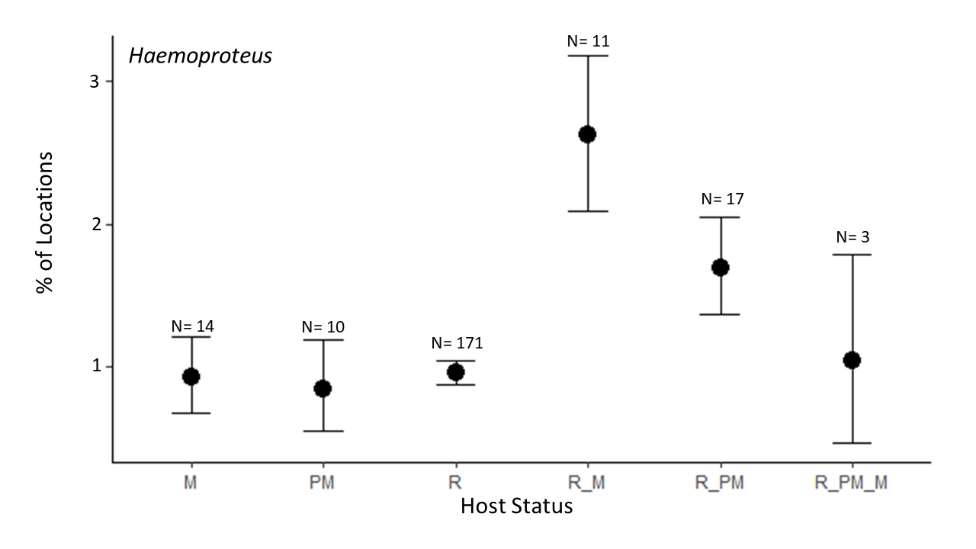

Figure 4: Mean (±SE) percentage of localities in which *Haemoproteus* lineages are detected according to the type of birds in which they are found. M = full migratory, PM = partial migratory, R = resident, R_M = resident and full migratory, R_PM = resident and partial migratory and R_PM_M = resident, partial migratory and full migratory. Number of lineages in each of the six categories are shown on the graph.

Our first mixed model revealed that there is no correlation between the percentage of migratory bird individuals per locality and local parasite richness (p = 0.19, Figure 5, Table 4). We also observed no effect of the percentage of migratory bird individuals on parasite richness when *Plasmodium* and *Haemoproteus* infections were treated separately (p = 0.55, p = 0.94, respectively; Figure S1 and S2, Table S1 and S2). Nevertheless, in all models we observed significant effects in parasite richness for other three predictors: host richness, prevalence and number of migrant individuals.

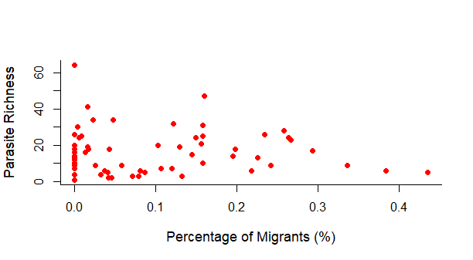

Figure 5: Local richness of haemosporidian parasites as a function of the percentage of migratory individuals out of all bird individuals sampled per locality. Each point represents a different locality. No correlation was found between percentage of migratory individuals and haemosporidian richness (p = 0.19).

For the second model, in which we analysed the relationship between local prevalence per bird species and local percentage of migratory bird individuals, we observed a negative correlation between migratory behavior and prevalence of haemosporidian parasites per species (p = 0.04, Figure 6 Table 5). However, when we repeated the analysis separately for only *Plasmodium* or *Haemoproteus* lineages, we observed no relation between percent of migrants and prevalence per host species (p = 0.08, p = 0.34, Figure S3 and S4, Table S3 and S4). None of the other predictors had any significant value on prevalence per bird species, whether when considering all haemosporidian lineages (Table 5), or only *Plasmodium* or *Haemoproteus* lineages (Tables S3 and S4).

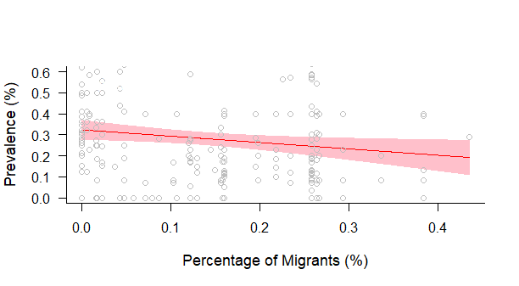

Figure 6: Correlation between prevalence of haemosporidian parasites and percentage of migratory host individuals per locality. Each point represents the prevalence value per host species per site. We observed a weak negative effect between migratory behavior and parasite prevalence (p = 0.04).

**4. Discussion**

We demonstrated that bird migratory behavior can connect parasite lineages through their migratory routes. Despite migration leading to lineages dispersal in South America, we did not observe higher parasite richness nor prevalence increase in regions with higher proportion of migratory bird populations. Indeed, haemosporidian prevalence decreased as the proportion of migratory individuals rose. Nevertheless, parasite richness was positively related to host richness, prevalence and number of migrant individuals, which could indicate possibly a positive relation between the absolute number of migratory birds in one region and parasite richness. Thus, migrant birds present an important role in the ecology and evolution of haemosporidian spread in South America.

Further, when analysing *Plasmodium* and *Haemoproteus* separately, we observed lineages present in resident and partial and full migrants possess different dispersal patterns. While for *Plasmodium* lineages we detected a much higher dispersal than other lineages categories, we noticed a spread rate similar to the one observed in resident birds for *Haemoproteus* parasites. It is known some *Plasmodium* parasites are highly generalists and able to infect a broad range of bird and vector hosts. For instance, *Plasmodium relictum* is able to infect at least 26 different species of Culicidae vectors and birds from many different orders (Valkiūnas 2005). The degree of which a parasite can shift between hosts certainly facilitate the putative dispersal of such organisms into new regions. Meanwhile, *Haemoproteus* spp. are, in general, more specialists parasites (Valkiūnas 2005, Okanga et al. 2014, Fecchio et al. 2020) what may reduce their ability to successfully develop in new regions with different ranges of vectors and bird species. In addition, despite the fact lineages shared by resident and migratory species presented the highest rates of presence in our localities, parasites infecting only full or partial migrant birds were present in a similar proportion of areas as the ones presented in only resident avian hosts. We believe the absence of sampling of certain migrant avian species in many areas could lead to a small percentage of localities in lineages found only in partial and full migrant birds since lineages infecting only migrant hosts may be specialists parasites. Besides, a single migrant species do not pass through all localities, reducing their percentage of sampling areas.

Dispersal of haemoporidians might be an important step into parasite diversification for local community composition since parasites, after establish into new regions, can evolve into new separate parasite lineages (Ellis et al. 2019, Fecchio et al. 2019). Indeed, Ellis et al. 2019 demonstrated South America presents the greatest proportion of sympatric nodes for *Plasmodium* spp. and one of the greatest *Haemoproteus* diversification rates, indicating high rates of parasite diversification in this region. Hence, considering the migrants contribution into parasite dispersal, these hosts might play a fundamental role in parasite evolution and diversification in South America. Indeed, many species migrate during breeding season and relapses mainly occurs after this period (Valkiūnas 2005), hence, facilitating parasite dispersal to new regions. However, we did not observe a clear relation between migrant birds presence and haemosporidian richness since our data suggests only the absolute number of migrants per location, but not proportion of migrant species and individuals, influences parasite richness. Indeed, the fact that most of our lineages were observed only in resident birds could explain the unclear relation between avian migrants and haemosporidian richness once haemosporidian greatest diversity develop in avian resident species. In addition, Hellgren et al. 2007 also suggest that new haemosporidian introductions into resident bird faunas are not common evolutionary events. Moreover, we observed that other factors such as host richness and prevalence also influence parasite richness. Therefore, it seems environmental and host features could be more important to determine parasite richness than dispersal patterns.

We also demonstrated that whereas migrant community percentage increases, haemosporidian prevalence reduces, indicating migrant birds presence can decrease parasite prevalence in bird community. In fact, migration allows species to escape environments with higher risks of infection, decreases infection levels and could favor the evolution of less-virulent pathogens (Altizer et al. 2011). These facts could lead to reduced haemosporidian prevalence in localities with higher proportion of migrant birds since long-distance migratory behavior can remove infected specimens from bird community as diseased animals are less likely to migrate because of the physiological requirements of migration and pathogens disease (Bradley and Altizer 2005, Altizer et al. 2011). However, Hahn et al. 2018 experimentally verified that haemosporidian low intensity infections do not affect bird capacity of migration, thus, most infected birds could still migrate and potentially spread their parasites into new areas. Meanwhile, the fact migration filters highly and moderately infected birds, which are the most likely to infect new vectors (Pigeault et al. 2015), allows community prevalence persists reduced. Certainly, further research should be performed to confirm the importance of migration behavior in mitigating haemosporidian community prevalence.

Thus, despite the fact previous research documented small influence of bird migration in parasite dispersal between Europe and Africa (Hellgren et al. 2007) or North America and Caribbean (Soares et al. 2019), we demonstrated that South America migrants can play an important role in parasite dispersal and, consequently, in their evolution and diversity. Nevertheless, as observed by Ricklefs et al. 2017, most lineages are not shared by resident and migrants species, indeed, most of our parasite lineages were observed only in resident birds, demonstrating resident host species holds the greatest parasite richness in our study system. We also demonstrated that, despite the fact migrants can carry haemosporidian to new localities, migration may do not affect parasite richness. In addition, migrants appear to possess a certain “protector effect” for bird communities in our study as their presence seems to be related to reduced community prevalence. Indeed, we presented a new analyses approach to compare pathogens distribution, beyond that, our analyses demonstrate migrants carry haemosporidian and possibly other pathogens thought their routes raising pathogens spread.

**Funding**

**Acknowledgments**

We thank MalAvi curators for maintaining the database and keeping all data available and all researchers who shared they data. Besides, we are grateful to all funding agencies that made this research possible. During the project, Alan Fecchio was supported by a postdoctoral fellowship (PNPD scholarship) from Coordenação de Aperfeiçoamento de Pessoal de Nível Superior (CAPES).

References

Alekseev, A. N. et al. 2001. Evidence of Ehrlichiosis Agents Found in Ticks ( Acari : Ixodidae ) Collected from Migratory Birds Evidence of Ehrlichiosis Agents Found in Ticks ( Acari : Ixodidae ) Collected from Migratory Birds. - J. Med. Entomol. 38: 471–474.

Altizer, S. et al. 2011. Animal migration and infectious disease risk. - Science (80-. ). 331: 296–302.

Bates, D. et al. 2015. Fitting linear mixed-effects models using lme4. - Stat. Softw. 67: 1–48.

Bauer, S. and Hoye, B. J. 2014. Migratory animals couple biodiversity and ecosystem functioning worldwide. - Science (80-. ). in press.

Bennett, D. J. et al. 2017. Treeman: An R package for efficient and intuitive manipulation of phylogenetic trees. - BMC Res. Notes 10: 1–10.

Bensch, S. et al. 2009. MalAvi: A public database of malaria parasites and related haemosporidians in avian hosts based on mitochondrial cytochrome b lineages. - Mol. Ecol. Resour. 9: 1353–1358.

Bradley, C. A. and Altizer, S. 2005. Parasites hinder monarch butterfly flight: Implications for disease spread in migratory hosts. - Ecol. Lett. 8: 290–300.

Braga, É. M. et al. 2011. Recent advances in the study of avian malaria: An overview with an emphasis on the distribution of Plasmodium spp in Brazil. - Mem. Inst. Oswaldo Cruz 106: 3–11.

Bürkner, P. C. 2017. brms: An R package for Bayesian multilevel models using Stan. - J. Stat. Softw. in press.

Callaway, R. M. and Ridenour, W. M. 2004. Novel weapons: Invasive success and the evolution of increased competitive ability. - Front. Ecol. Environ. 2: 436–443.

Comitê Brasileiro de Registros Ornitológicos - CRBO 2014. Listas das aves do brasil. - Com. Bras. Regist. Ornitológicos: 1–38.

Consoli, R. A. G. B. and Oliveira, R. L. de 1994. Principais mosquitos de importância sanitária no Brasil. - Fiocruz.

Ellis, V. A. et al. 2019. The global biogeography of avian haemosporidian parasites is characterized by local diversification and intercontinental dispersal. - Parasitology 146: 213–219.

Fallon, A. S. M. et al. 2003. Detecting Avian Malaria : an Improved Polymerase Chain Reaction Diagnostic Detecting Avian Malaria : an Improved Polymerase Chain. 89: 1044–1047.

Fecchio, A. et al. 2019. Avian host composition, local speciation and dispersal drive the regional assembly of avian malaria parasites in South American birds. - Mol. Ecol. 28: 2681–2693.

Fecchio, A. et al. 2020. Evolutionary ecology, taxonomy, and systematics of avian malaria and related parasites. - Acta Trop.: 105364.

Ferreira-Junior, F. C. et al. 2018. A new pathogen spillover from domestic to wild animals: Plasmodium juxtanucleare infects free-living passerines in Brazil. - Parasitology: 1–10.

Ferreira, F. C. et al. 2017. Habitat modification and seasonality influence avian haemosporidian parasite distributions in southeastern Brazil. - PLoS One in press.

Gonzalez-Quevedo, C. et al. 2014. Predictors of malaria infection in a wild bird population: Landscape-level analyses reveal climatic and anthropogenic factors. - J. Anim. Ecol. 83: 1091–1102.

Hahn, S. et al. 2018. Low intensity blood parasite infections do not reduce the aerobic performance of migratory birds. - Proc. R. Soc. B Biol. Sci. in press.

Hellgren, O. et al. 2004. A New Pcr Assay For Simultaneous Studies Of Leucocytozoon, Plasmodium, And Haemoproteusfrom Avian Blood. 90: 797–802.

Hellgren, O. et al. 2007. Detecting shifts of transmission areas in avian blood parasites - A phylogenetic approach. - Mol. Ecol. 16: 1281–1290.

Kembel, S. W. et al. 2010. Picante: R tools for integrating phylogenies and ecology. - Bioinformatics 26: 1463–1464.

Lacorte, G. A. et al. 2013. Exploring the Diversity and Distribution of Neotropical Avian Malaria Parasites - A Molecular Survey from Southeast Brazil. - PLoS One 8: 1–9.

Lindeborg, M. et al. 2012. Migratory Birds, Ticks, and Crimean-Congo Hemorrhagic Fever Virus. - Emerg. Infect. Dis. 18: 2095–2097.

Marzal, A. 2012. Recent Advances in Studies on Avian Malaria Parasites. - Malar. Parasites: 135–158.

Morshed, M. G. et al. 2005. Migratory songbirds disperse ticks across Canada, and first isolation of the Lyme disease spirochete, Borrelia burgdorferi, from the avian tick, Ixodes auritulus. - J. Parasitol. 91: 780–790.

O’Connor, E. A. et al. 2020. Wetter climates select for higher immune gene diversity in resident, but not migratory, songbirds. - Proceedings. Biol. Sci. 287: 20192675.

Okanga, S. et al. 2014. Host specificity and co-speciation in avian haemosporidia in the Western Cape, South Africa. - PLoS One in press.

Paradis, E. and Schliep, K. 2018. ape 5.0: an environment for modern phylogenetics and evolutionary analyses in R. - Bioinformatics 35: 526–528.

Pigeault, R. et al. 2015. Avian malaria: a new lease of life for an old experimental model to study the evolutionary ecology of Plasmodium. - Philos. Trans. R. Soc. Lond. B. Biol. Sci. 370: 323–330.

Poupon, M. et al. 2006. Prevalence of Borrelia burgdorferi Sensu Lato in Ticks Collected from Migratory Birds in Switzerland Prevalence of Borrelia burgdorferi Sensu Lato in Ticks Collected from Migratory Birds in Switzerland. - Appl. Environ. Microbiol. 72: 976–979.

Prenter, J. et al. 2004. Roles of parasites in animal invasions. - Trends Ecol. Evol. 19: 385–390.

Remsen, J. V. J. et al. A classification of the bird species of South America. - Am. Ornithol. Soc.

Revell, L. 2012. phytools: An R package for phylogenetic comparative biology (and other things). - Methods Ecol. Evol 3: 217–223.

Ricklefs, R. E. et al. 2017. Avian migration and the distribution of malaria parasites in New World passerine birds. - J. Biogeogr. 44: 1113–1123.

Soares, L. et al. 2019. Neotropical migratory and resident birds occurring in sympatry during winter have distinct haemosporidian parasite assemblages. - J. Biogeogr.: 1–12.

Somenzari, M. et al. 2018. An overview of migratory birds in Brazil.

Turchetto-Zolet, A. C. et al. 2013. Phylogeographical patterns shed light on evolutionary process in South America. - Mol. Ecol. 22: 1193–1213.

Valkiūnas, G. 2005. Avian Malaria Parasites and other Haemosporidia.

Zamora-Vilchis, I. et al. 2012. Environmental temperature affects prevalence of blood parasites of birds on an elevation gradient: Implications for disease in a warming climate. - PLoS One in press.

Table 1: Parameter estimates, standard errors, and p values for the Bayesian model testing the differences in the distribution of haemosporidian lineages among those that occur in migratory and/or resident avian host species.

|  |  |  |  |
| --- | --- | --- | --- |
|  | **Estimate** | **Std. error** | **p** |
| Full migrant | -4.64 | 0.11 | <0.001 |
| Partial migrant | -0.04 | 0.18 | 0.81 |
| Resident | 0.09 | 0.11 | 0.42 |
| Resident and full migrant | 0.88 | 0.15 | <0.001 |
| Resident and partial migrant | 0.76 | 0.14 | <0.001 |
| Resident, partial and full migrant | 1.56 | 0.17 | <0.001 |

Table 2: Parameter estimates, standard errors, and p values for the Bayesian model testing the differences in the distribution of *Plasmodium* lineages among those that occur in migratory and/or resident avian host species.

|  |  |  |  |
| --- | --- | --- | --- |
|  | **Estimate** | **Std. error** | **p** |
| Full migrant | -4.77 | 0.20 | <0.001 |
| Partial migrant | 0.08 | 0.28 | 0.76 |
| Resident | 0.24 | 0.20 | 0.24 |
| Resident and full migrant | 1.03 | 0.25 | <0.001 |
| Resident and partial migrant | 1.02 | 0.23 | <0.001 |
| Resident, partial and full migrant | 2.83 | 0.23 | <0.001 |

Table 3: Parameter estimates, standard errors, and p values for the Bayesian model testing the differences in the distribution of *Haemoproteus* lineages among those that occur in migratory and/or resident avian host species.

|  |  |  |  |
| --- | --- | --- | --- |
|  | **Estimate** | **Std. error** | **P** |
| Full migrant | -4.68 | 0.15 | <0.001 |
| Partial migrant | -0.10 | 0.24 | 0.70 |
| Resident | 0.04 | 0.16 | 0.86 |
| Resident and full migrant | 1.07 | 0.19 | <0.001 |
| Resident and partial migrant | 0.61 | 0.18 | <0.001 |
| Resident, partial and full migrant | 0.09 | 0.37 | 0.75 |

Table 4: Parameter estimates, standard errors, and p values for the mixed model testing the variation of haemosporidian richness as a function of the percentage of migratory individuals out of all individual birds sampled per locality, as well as other potential predictors.

|  |  |  |  |
| --- | --- | --- | --- |
|  | **Estimate** | **Std. error** | **P** |
| Intercept | -6.51 | 2.53 | 0.01 |
| Percentage of migrant individuals | -33.05 | 24.90 | 0.18 |
| Host richness | 0.3 | 0.16 | >0.001 |
| Prevalence | 0.44 | 0.07 | >0.001 |
| Percentage of migrant species | 0.09 | 0.30 | 0.77 |
| Number of migrants | 0.08 | 0.26 | 0.0013 |

Table 5: Parameter estimates, standard errors, and p values for the mixed model testing the variation of local haemosporidian prevalence per species as a function of the percentage of migratory individuals out of all individual birds sampled per locality, as well as other potential predictors.

|  |  |  |  |
| --- | --- | --- | --- |
|  | **Estimate** | **Std. error** | **p** |
| Intercept | 0.33 | 0.05 | >0.001 |
| Percentage of migrant individuals | -1.36 | 0.68 | 0.04 |
| Host richness | >0.001 | >0.001 | 0.69 |
| Parasite richness | -0.001 | 0.001 | 0.40 |
| Percentage of migrant species | >0.001 | >0.001 | 0.21 |
| Number of migrants | -0.001 | 0.001 | 0.27 |